**Inventory and Asset**

**Management**

Project Proposal

By

**Mr. Nathawut Supavananusorn 542115020**

**Mr. Tanadol Parn-ong 542115021**

Department of Software Engineering

College of Arts, Media and Technology

Chiang Mai University

Project Advisor

________________________

**Dr. Prompong Sugunnasin**

**Document History**

|  |  |  |  |  |  |  |
| --- | --- | --- | --- | --- | --- | --- |
| **Document Name** | **Version** | **Status** | **Date** | **Viewable** | **Reviewer** | **Responsible** |
| **Documents** | | | | | | |
| Inventory and Asset Mangement_v0.1.docx | Create Chapter One  -Abstract  -Introduction and Background | Release | 5 May 2015 | NS, TP, PS | NS,TP | TP |

**\*NS = Nathawut Supavananusorn**

**\*TP = Tanadol Parn-ong**

**\*PS = Dr. Prompong Sugunnasin**

**Abstract**

Currently, the technician in many organizations usually have problems with the division of tasks and responsibilities. Which these problems affect to delay repairing and follow-up. These problems can cause customer dissatisfaction is huge.

In this project, we plan to develop the web application for support repairing management. Inventory and Asset Management is a system that helps the user to manage and divide the works to each of the technicians equally. Inventory and Asset Management will made the technician easy to view work and progress of the repair. This system will help the user to comfortable so much. The system provides the user to identify and verify spare parts that can use it or it had broken and view the lifetime of spare parts.

User can use Inventory and Asset Management for repairing management. The technician has divided up the task and works from system equally. The technician can check his task and progress of the repair work.

Contents

**Chapter One | Introduction and Background** 5

# **Chapter One | Introduction and Background**

Nowadays, the technicians have problem with items are out of order within College of Arts, Media and Technologies. As a result, the various work within College of Arts, Media and Technologies was slow and unbalance. When the technician cannot verify the operation of remaining repair, the technician will not know the details of the repair work to do. Which the technicians may check it over and over again. These problems can affect in College of Arts, Media and Technologies management so much. Sometimes, each of the technicians gets unequal work which they get the same income. This event may cause conflicts within College of Arts, Media and Technologies.

Most organizations need the ways to manage and divide the work of technicians so nicely and equally. College of Arts, Media and Technologies has sought to find a way to prevent the exploitation of technicians within College of Arts, Media and Technologies. And look for the modern spare parts system for making it easier to check and distribute the product. In addition, College of Arts, Media and Technologies need many the technicians because not enough for manage the repair works within the college which this project will help and support in this part.

So we decided to do this project up, this project is about repairing management within College of Arts, Media and Technologies. We have invented the system for manage spare parts or the product that will use the repair. This system provides the user to check the progress of repair work accurately. To facilitate both the technician and College of Arts, Media and Technologies. This system will give a new experience to the user in repair management within College of Arts, Media and Technologies.

# **Chapter Two | Literature Review**

## **2.1 Business Review**

### 2.1.1 iSoftService [1]

iSoftService is an application about repair management system. This system are used by the repair center. This system help to manage the product repairing, and notify to technicians about their work. iSoftService supports major features as follows,

1. This system provides technicians to manage their repairing works.
2. This system provides technicians to record repairing works.
3. This system provides technicians to find their works.
4. This system provides technicians to check the progress of repairing works.

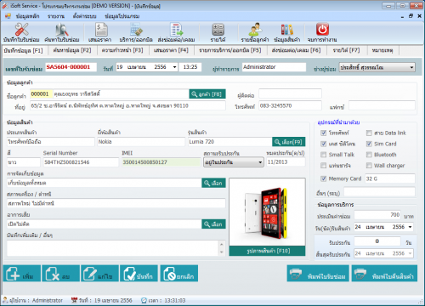

*Figure 1 iSoftService main page Demo Version*

Figure 1 shows the interface of item information page where users can input item information that is repaired. On the right side of Figure 1 provide the user to select an item that is repaired and to display after sales service time.

Pros

iSoftService provide several functions about repairing system for technicians such as record repairing information, find repairing information, calculate income, and other functions. This system provides repairing collaboration between departments in the service center.

Cons

Users must spend a lot of money for purchasing the iSoftService license. This system has weakness because technicians spend time very much to distribute works of each technician equally. iSoftService user interface has function complexity, so this system is difficult to use for beginning user.

### 2.1.2 Service Center [2]

Service Center is developed for the organization, which is a service center for repair and installation, such as appliance repair service center, PC repair shop, and mobile repair shop. This system is convenient for the general repair shop. Service Center supports major features as follows,

1. This system provides the user to record service and repair work.
2. This system provides the user with search product, the status of repair works.
3. This system provides interaction between system and user with friendly interactive.
4. This system provides the user to check information and the progress of repair works.

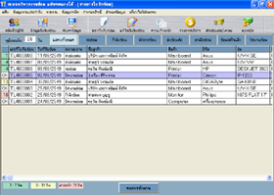

*Figure 2 Service Center main page*

Figure 2 shows the interface of the main page where users can view and manage repair information. On the top side of Figure 2 provide the user to use the menu for repair management.

Pros

Service Center is an application that provides convenient to repairing technicians. This system provides basic functions to manage repair information such as the user account and user permission, search information, and other essential functions, which are appropriate general repair shops.

Cons

This system needs to spend a lot of money for purchase a license for use. This system has obsolete repair system that technicians must spend too much time on repair management and distribute works of each technician equally. Service Center is hard to use for the user who does not have experience about repair management because there functions a diverse and scattered in a single system.